Paste To Notebook

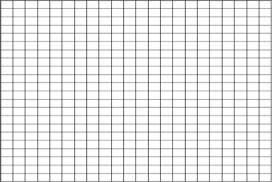

**X-Axis**

**Graphing In Science**

Y-Axis