Name ___________________________________
Date _________________
Hour ________
Group Number ________

Challenge: In this challenge you will be designing an army launcher. Your goal is to get your army man to travel the farthest distance using only the supplies you are given. You will not be given additional materials.
Materials:
- 1 Paper Cup - 1 Army Man - 1 Spoon - 6 Popsicle Sticks
- 2 Rubber Bands - 2 Feet of Tape - Measuring Tape - Timer

Initial Design: What materials are you using in your initial design? Draw and label a diagram of your design below.
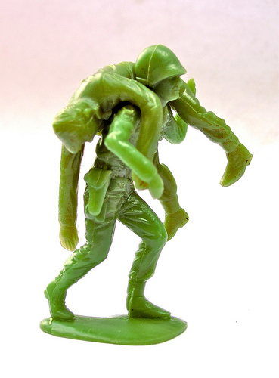

Trial | Distance (cm) | Time (sec)
1
2
3
Average
Original Test: We will be measuring the distance in centimeters from the starting point of the launch to where your army man lands on the ground. We also will be measuring the amount of time your army man spends in the air from when it is released to the time it hits the ground. Each group will have 3 trials and must record each launch in the table below. Make sure to label the units correctly in the chart.
Improvements: Describe ways you could improve the launcher. What can you change to the design so the pumpkin can go further than your first trials?

Final Design: What materials are you using in your final design? Draw and label a diagram of your design below.

Final Test: Again, we will be measuring the distance in centimeters from the starting point of the launch to where your army man lands on the ground. We also will be measuring the amount of time your army man spends in the air from when it is released to the time it hits the ground. Each group will have 3 trials and must record each launch in the table below. Make sure to label the units correctly in the chart.
Trial | Distance (cm) | Time (sec)
1
2
3
Average
Individual Reflections:
- What was the average distance your army man travelled?
(Add together both the original average and the final average and divide by 2)

- What was the average time your army man was in the air?
(Add together both the original time and the final time and divide by 2)

- What was the average speed the army man travelled? (Speed= Distance/Time)

- What about your design was successful?

- What about your design would you change if you could do it again?

